|  |  |  |  |  |  |
| --- | --- | --- | --- | --- | --- |
| Date | 13-Dec-22 | | | Tester Name | Richard Belanger |
| Environment | Penfax - Test | | | Login used | TEST2 |
| Operating System | Select OS | Version: | Update: | | |
| Software Used | Select Software | Version: | Update: | | |
| Select Software | Version: | Update: | | |
| Release version | 22.4.1 | | | | |
| Title | M27 Reversal and Adjustment through OLC and DCT | | | | |
| Test Type | Regression | | | | |
| Test Scenario | M27.01 Reverse a Termination | | | | |
|  |  | | | | |
| Expected Results | Employment End Date should be removed.  Member Status should become Active.  Vesting Service should start calculating services. | | | | |
| Pass/Fail | Pass | | | JIRA# | N/A |

Describe your steps with screenshots:

1. Bring up a terminated MEPP member who was terminated in error. Note down calculated services and HAS.

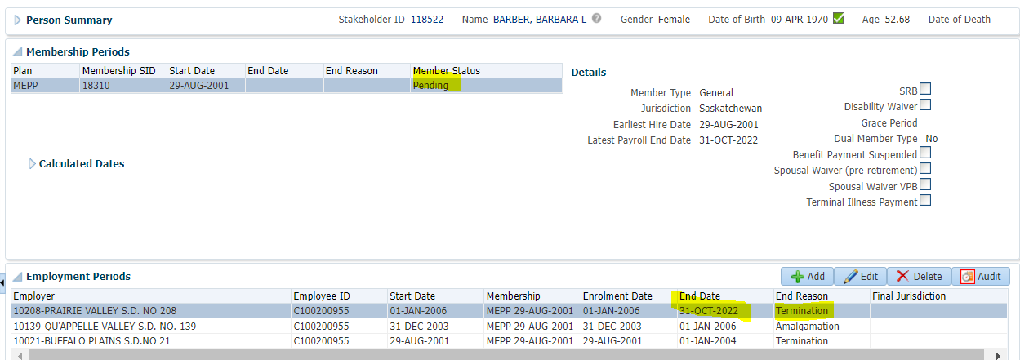

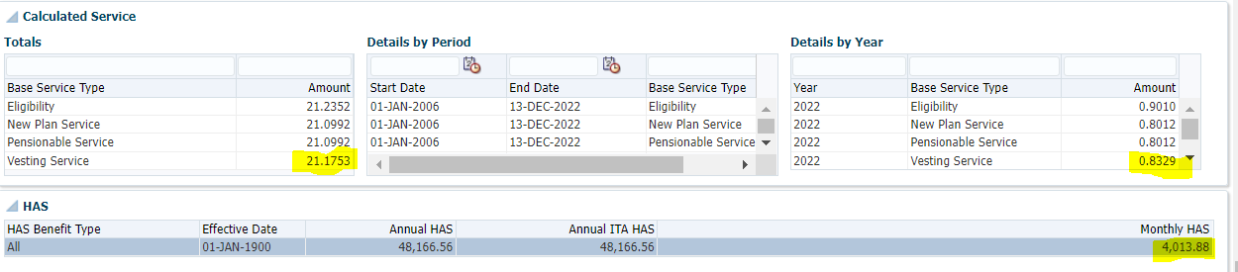

1. Employee Profile>Click Edit

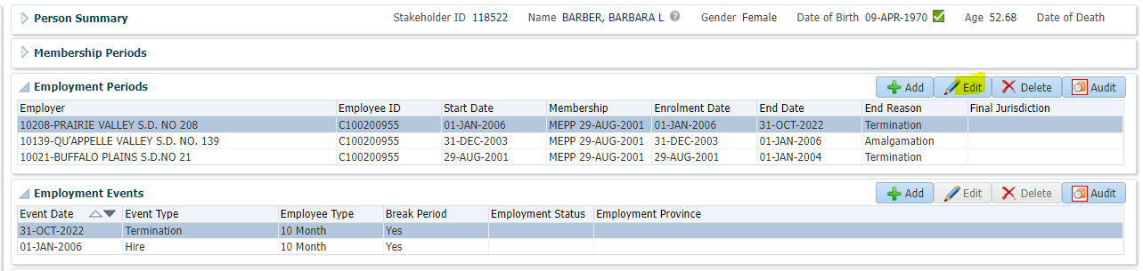

1. Under Employment Period. Remove End Date and End Reason and click on Save.

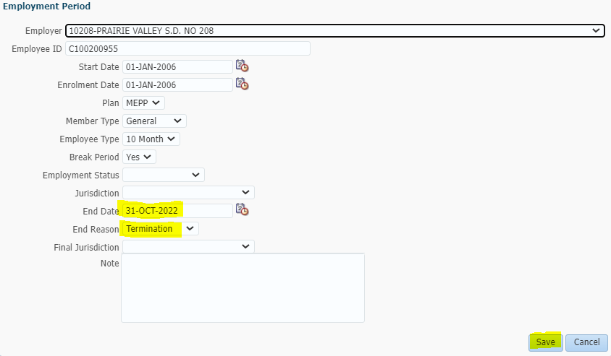

Member back to Active

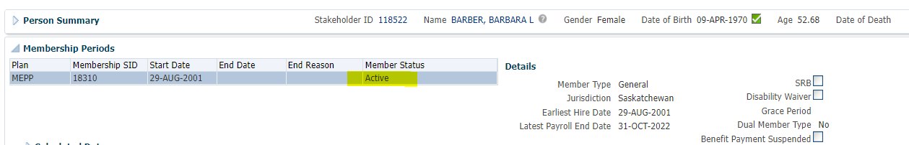

1. Go to Member Profile. Member Status is now Active and Vesting Service has started calculating services.

